Happy New Year to all WildCookham’s friends. As we work off the seasonal festivities it’s a good time for us all to take a look at what we’ve achieved in the past year and look ahead. We hope you have enjoyed what has been a busy year for us. And that you’ll be with us for an even busier 2019!

NEWSLETTER
January 2019
June 2018

Creating awareness
2018 saw us stepping up our activities in several ways. Building on our programme of monthly talks and walks, we took on our first surveys of local wildlife and habitats and, as the year ended, took the first steps to managing our own nature reserve. Many of you joined us at events covering a wide range of interests – swans, bats, veteran trees, landscape ecology, dragonflies, wildflowers, wetlands, insects, fungi, glowworms, birdsong, moths. And, mid year, around 100 of us listened to a talk by one of the world’s leading environmental academics. We helped toads travel safely to and from their breeding sites; we made nest boxes thanks to the Bisham Nest Box Group; we took children on a nature trail; and we met at the Jolly Farmer to see which moths we had trapped overnight.
Back to Basics: what have we got?
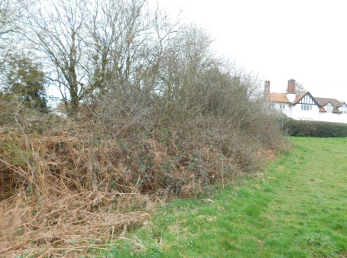
The challenges of accelerating habitat loss and climate change mean that we need to do more. One of the first steps is to know what we have today which led to the start of a programme of surveys looking at all aspects of our local biodiversity. Supporting the Parish Council Rob Acker formed a team of volunteers to survey our local footpaths and have presented initial findings on this. Our next step was to create a team, led by Derek and Gwen Tyler, to look at all of the ponds in the Cookhams to determine first where they are and then begin assessing their quality and ability to support life. A more specific project, led by Brian Clews, was to check on the existence of Variable Damselflies, a species known to exist locally but under threat.
Our first Reserve
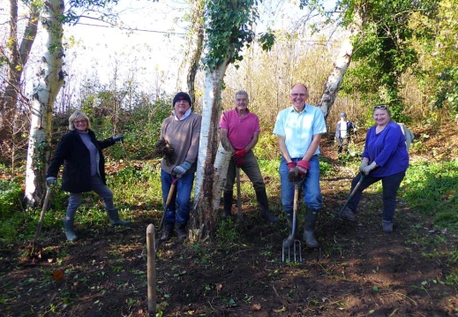
Our first foray into reserve management has come with the opportunity to take on responsibility for the Harris Woodbridge, a small area of old garden/woodland off Dean Lane, owned by the Parish Council. Mike Day took on leadership for this exciting project and around 20 people were there in November to start clearing enough of the area so that we can see more clearly what’s there. We plan to encourage the area as a wild garden and will be working through 2019 on this project, with at least monthly working party days to which all are welcome.
Harris Woodbridge Reserve

Combining Forces
We have also started conversations with other local organisations where we have shared interests – the National Trust, the Woodland Trust, BBOWT (the local wildlife trust), Waltham Place, local farmers and the John Lewis Partnership. John Lewis owns more than 300 acres across the Odney Club and the Winter Hill Golf Club and they are keen to work with us. More generally, achieving a meaningful impact on our local habitats will require the support of the major local landowners and it’s good to note the positive responses received. We have also had discussions with Maidenhead Waterways to assess the impact of their plans for flowing water through Maidenhead on our local habitats.
Key to our work is the close relationship with Wild Maidenhead. This group works across 11 of the Maidenhead Borough wards and have similar aims to ourselves. They also lead the drive to get the Biodiversity Action Plan adopted across the Borough and part of this involves highlighting 20 target species across the full range of wildlife. We heard about these at our December meeting and will be supporting their efforts through 2019.
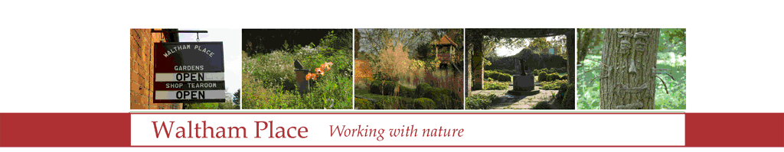

Wild About Everything!
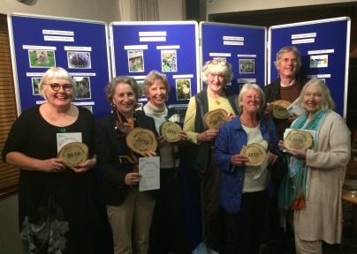
A major success during the year was the launch of the Wild About Gardens Awards, a high profile project designed to engage local people directly in making their gardens a welcoming home for wildlife. 50 gardens across the Cookhams were entered, with 27 receiving a Gold Award plaque. The Awards were being trialled in Cookham and, following our success, they will be extended across Maidenhead by Wild Maidenhead this year.
The Wild message has also been applied to our Wild About Cookham Photography Competition. This will lead to an exhibition at this year’s Cookham Festival, with plans for a 2020 WildCookham calendar and we look forward to entries from people of all ages across Cookham and beyond. All the information about this is on the Cookham Festival home page (cookhamfestival.org.uk).
What’s in store for 2019?
We’ll be continuing our programme of talks and walks aimed at stimulating interest in and awareness of the richness of our local habitats. Look out for news of these on our Meetup site.
We shall move forward with our surveys of hedges/footpaths and ponds to establish more clearly what steps need to be taken to ensure that all of these habitats are able to support biodiversity to the fullest extent.
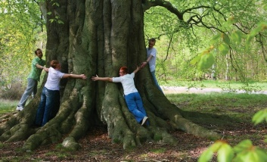
An important new project is to survey all of the ‘veteran trees’ in the Cookhams. Led by Lars Ahlgren this team is tasked with mapping all trees above a given size and ensuring that these are stored on a national database. When we realise that, in all of Cookham, only one tree currently appears on the database you’ll understand it’s an essential job.
A really exciting development will be our liaison with local schools. We have given talks to the primary schools in past years at the time of the Big Garden Birdwatch: now we want to extend this. Vicci-Lee Pearson, herself an ex-teacher, has taken on the lead for this and will be working with the schools defining what type of activity makes sense for them. Ensuring our young people appreciate the significance of our wildlife is key to ensuring that future generations will protect it.
As we do more we need more people with relevant wildlife knowledge so we shall be creating a skills database and we need your help with this. You don’t have to be a degree-holding expert! Anyone with reasonable knowledge of particular areas of our wildlife and wild habitats can help – and we can help with training workshops to help you learn more. Look out for our contact with you about this or contact us now if you have something to offer.
Keeping in touch
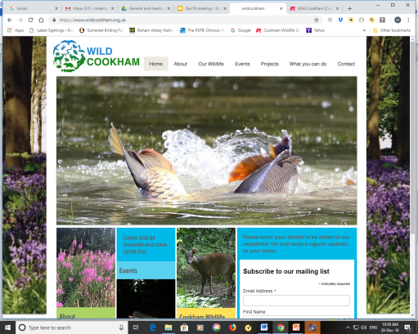
We use Meetup (meetup.com/WildCookham) to tell you about our events and that will continue. Do please sign up to get the Meetup notices if you can: it helps us gauge how many will attend each meeting. Lou Young has lots of support from many people in ensuring that our Facebook page (facebook.com/groups/wildcookham) is kept busy – sharing news and also providing a place you can go to get answers to your wildlife questions. We have lacked a website but this is now being addressed and an early version of the site is now available (cookham.org.uk). This will be populated with information, access to resources and the like over the coming months.
The Power of Volunteers
All of this activity has only been possible with the help of a growing army of volunteers – and, essentially, a number of individuals who have taken responsibility for each of the projects we undertake. A massive thank you to them and to all who have helped in so many ways. We need even more of you this year! Please contact any of the committee below.
WHY?
A final point. Let’s remember why this work is so important. We have lost 97% of our wildflower meadows since the 1940s; 50% of our ponds have disappeared in the last century and 80% of the remaining ones are of poor quality; 50% of our hedgerows have been destroyed in the lifetime of many people reading this; insect populations across Europe have fallen by up to 75% in the past 30 years; farmland bird populations are down typically by between 50 and 95%. We have created this potentially catastrophic situation: we need to attempt to stop it getting worse. The good news is that nature is remarkably resilient: give it a chance and it will recover and quickly. Please help us help it.

The WildCookham Team
(Feel free to contact any of us)

Rob Acker (Hedgerows and Footpaths survey) hawthorn.rob@googlemail.com
Lars Ahlgren (Veteran trees survey) ahlgrenlars@hotmail.com
Cindy Barnes (Committee) cindygreener@btinternet.com
Brian Clews (Committee) brian.clews@btconnect.com
Mike Copland (Chair) mikecopland7@gmail.com
Andrew Padmore (Committee) andrewpadmore8@gmail.com
Stephanie Papillon (Treasurer) stephp246@yahoo.co.uk
Vicci-Lee Pearson (Schools Liaison) viccilee.pearson@yahoo.co.uk
Lynne Peperell (Committee) lpeperell@f2s.com
Charlotte Serpell (Committee) charlotte_serpell@hotmail.com
Derek Tyler (Ponds survey) derektyler@hotmail.com
Lou Young (Committee) lou98y@hotmail.com

